COMPILER DESIGN

EXP 4

RE TO NFA EXPRESSION

Aman Kalla

RA1911003010640

Source Code:-

#include <stdio.h>

#include <conio.h>

#include <ctype.h>

#include <string.h>

void main()

{

char m[20],t[10][10];

int n,i,j,r=0,c=0;

printf("\n\t\t\t\tSIMULATION OF NFA");

printf("\n\t\t\t\t*****************");

for(i=0;i<10;i++)

{

for(j=0;j<10;j++)

{

t[i][j]=' ';

}

}

printf("\n\nEnter a regular expression:");

scanf("%s",m);

n=strlen(m);

for(i=0;i<n;i++)

{

switch(m[i])

{

case '|' :

{

t[r][r+1]='E';

t[r+1][r+2]=m[i-1];

t[r+2][r+5]='E';

t[r][r+3]='E';

t[r+4][r+5]='E';

t[r+3][r+4]=m[i+1];

r=r+5;

break;

}

case '*':

{

t[r-1][r]='E';

t[r][r+1]='E';

t[r][r+3]='E';

t[r+1][r+2]=m[i-1];

t[r+2][r+1]='E';

t[r+2][r+3]='E';

r=r+3;

break;

}

case '+':

{

t[r][r+1]=m[i-1];

t[r+1][r]='E';

r=r+1;

break;

}

default:

{

if(c==0)

{

if((isalpha(m[i]))&&(isalpha(m[i+1])))

{

t[r][r+1]=m[i];

t[r+1][r+2]=m[i+1];

r=r+2;c=1;

}

c=1;

}

else if(c==1)

{

if(isalpha(m[i+1]))

{

t[r][r+1]=m[i+1];

r=r+1;

c=2;

}

}

else

{

if(isalpha(m[i+1])){t[r][r+1]=m[i+1];

r=r+1;

c=3;

}

}

}

break;

}

}

printf("\n");

for(j=0;j<=r;j++)

printf(" %d",j);

printf("\n___________________________________\n");

printf("\n");

for(i=0;i<=r;i++)

{

for(j=0;j<=r;j++)

{

printf(" %c",t[i][j]);

}

printf(" | %d",i);

printf("\n");}

printf("\nStart state: 0\nFinal state: %d",i-1);

getch();

}

Output:-

1. (a/b)*a

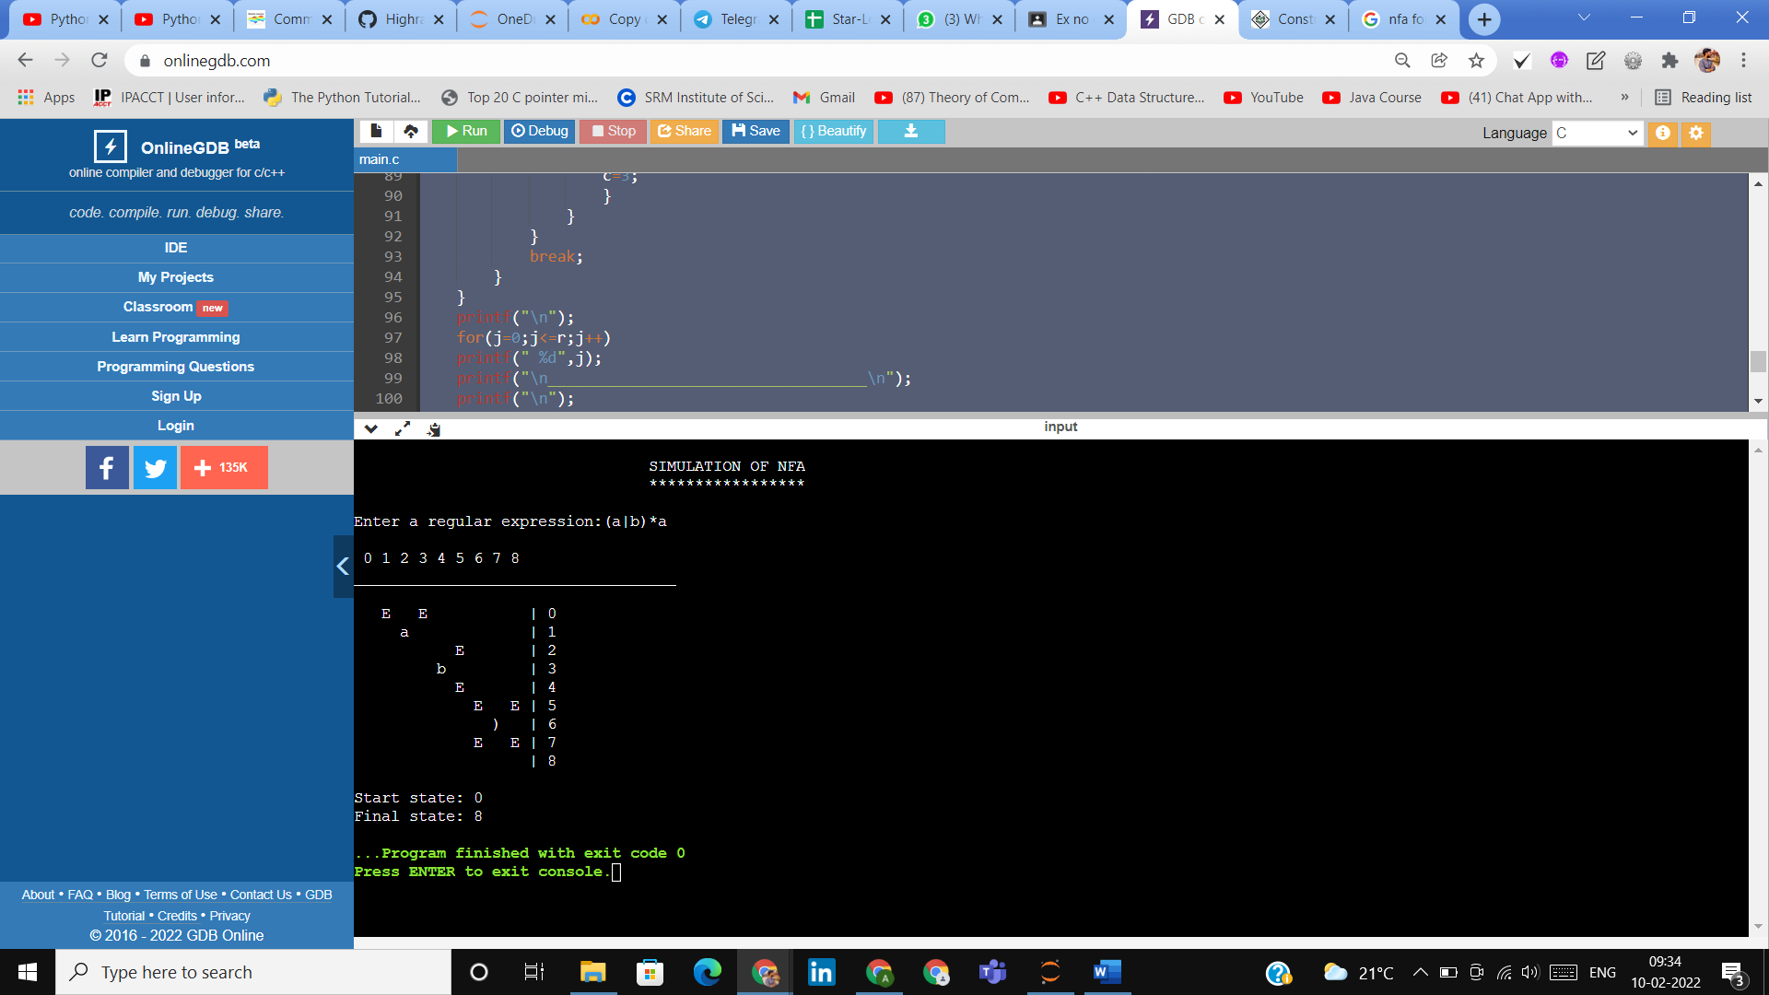

1. a+ba*

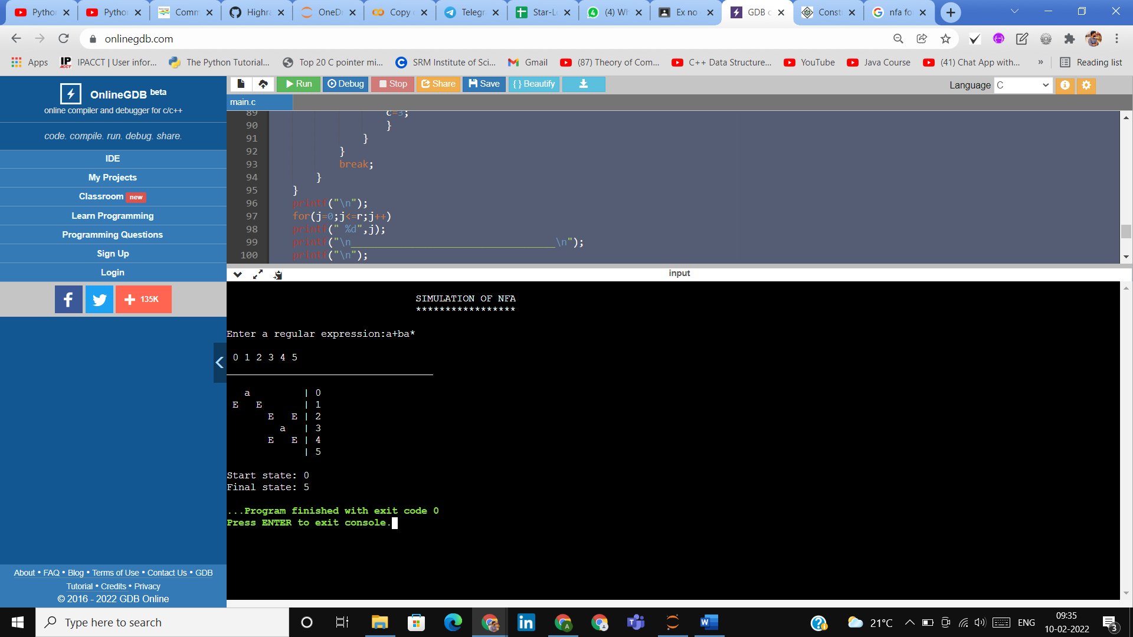

1. b+ba*

